Stretching is an important part of your recovery. Perform each exercise 3 times a day to achieve best results.

Remember to start off slowly! You should ***NOT*** feel pain but instead a “gentle pulling”.

1. Perform each exercise 3 times on both left and right. 2) Hold each for 10-15 seconds. 3) Stretch gently. 4)Don’t bounce

Stretch 3 times a day!

STOP. If you feel pain

**1.**

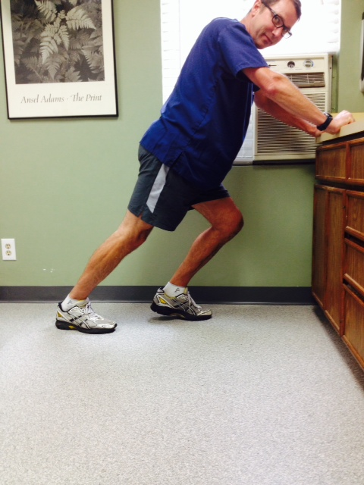

**2.**

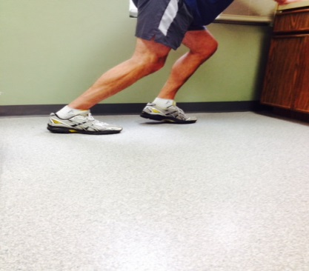

**Exercise 4:** Stand on the edge of a bottom step with your heel hanging off of the edge. Hold on to the railing. Slowly lower one heel below the step while keeping your **knee slightly bent** until you feel the stretch and **hold for 10-15 seconds.** Alternate and repeat.

**Exercise 2:** Lean forward against a wall or countertop. Place the leg you’re stretching behind the other with the knee bent. Keep your heel on the floor and lean toward the counter until you feel the stretch. **Hold for 10-15 seconds**. Alternate and repeat.

**Exercise 3:** Stand on the edge of a bottom step with your heel hanging off of the edge. Hold on to the railing. Slowly lower one heel below the step while keeping your **knee straight** until you feel the stretch. **Hold for 10-15 seconds**. Alternate and repeat.

**Exercise 1:** Lean forward against a wall or counter. Place the leg you’re stretching behind the other with the knee straight. Keep your heel on the floor and lean toward the wall until you feel the stretch in the calf muscle. **Hold for 10-15 seconds**. Alternate and repeat.

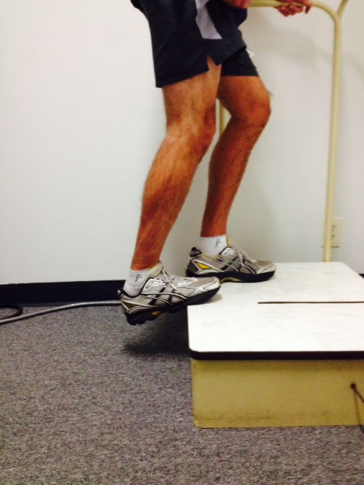



**4.**

**3.**