FREE COMMUNITY EVENT
GOOD BLOOD FLOW: HEART TO TOE

Do You Have…
- Leg Pain?
- Diabetes?
- High Blood Pressure?
- High Cholesterol?
Reduce your risk of heart attack, stroke and limb loss.
Wit
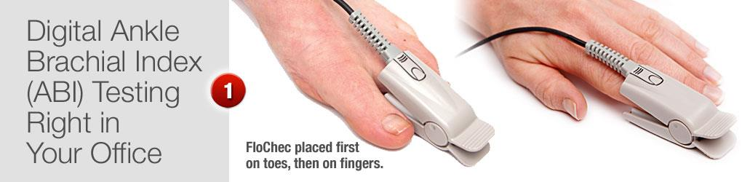

Free
HEALTH Screening

SATURDAY, February 28th 11:30–2:30 pm

Free, confidential PAD and foot health screening from certified podiatrists.
Sol Foot & Ankle Centers
5406 E Village Rd.
Long Beach, CA 90808
(562) 496-3846
WWW.SOLFOOT.COM
Sol Foot & Ankle Centers in Long Beach will be conducting a free health screening to raise awareness for Peripheral Arterial Disease (PAD). Stop by to receive:

- Painless, non-invasive blood flow test
- Circulation checked by a physician
- Treatment recommenda
- tions
- Info & Literature about PAD
- Snacks, beverages & much more!

Don’t forget to bring a friend or family member!

5406 E. Village Road in Long Beach
Located in the Parkview Village Shopping Center on the corner of Bellflower Blvd. & Carson St.

